

Quality Evaluation Report



Yousuf Dar

Junaid Raza Mahmood

Matthew Dewhurst

Ayesha Karim

Asnain Mahmood

Harpreet Singh

Amar Ashfaq

Ahmed Abduulwaise Abdulkadir

CONTENTS

1. INTRODUCTION……………………………………………………………………………….2

2. SOFTWARE QUALITY………………………………………………………………………...2

3. SOFTWARE QUALITY ATTRIBUTES AND HOW THEY WERE ACHIEVED…………...3

3.1 FUNCTIONAL SUSTAINABILITY………………………………………………...4

3.2 PERFORMANCE EFFICIENCY…………………………………………………..4

3.3 COMPATIBILITY…………………………………………………………………...5

3.4 USABILITY………………………………………………………………………….6

3.5 RELIABILITY…………………………………………………………………........6

3.6 SECURITY………………………………………………………………………….6

3.7 MAINTAINABILITY…………………………………………………………….......6

3.8 PORTABILITY……………………………………………………………………...7

3.9 REUSABILITY/MODULARITY……………………………………………………7

4. TESTING………………………………………………………………………………………...8

4.1 BLACK-BOX TESTING……………………………………………………… 8

4.1.1 SCREENSHOTS………………………………………9

4.2 FUNCTION TESTING……………………………………………………… 10

4.3 ACCEPTANCE TESTING……………………………………………………11

5. SOFTWARE FUNCTIONAL/NON-FUNCTIONAL QUALITIES……………………………12.

6. MEETINGS……………………………………………………………………………………..12

7. ITERATIVE PROCESSES…………………………………………………………………….13

8. HOW WE FUNCTIONED AS A TEAM ………………………………………………………13

9. WHAT WORKED WHAT DIDN'T……………………………………………………………..13

10. WHAT WAS ACHIEVED VS WHAT WAS PLANNED…………………………………….14

10.1 PLAN - FIGURE A…………………………………………………………..14

10.2 QUALITY ASSURANCE PLANS - FIGURE B….........................................14

11. CONCLUSION………………………………………………………………………………...15

12. REFERENCES………………………………………………………………………………....16

**Tales of Conquest**

**1 Introduction**

As part of stage 1 we had efficiently formed our teams and were required to participate in different group related activities. This allowed us all too effectively build some sort of understanding as well as rapport and as a result work in tandem to achieve the goals set. We then discussed some of the crucial factors in having an encouraging and positive working atmosphere. We concluded with the most important factor being everyone putting in 100% effort when conducting work as the success of the project was reliant upon everyone doing their own allocated duties to the best of their ability.

Our first submission was a designed alliance in which we documented our commitments to each other and how we would work as a team. This document allowed us to establish the foregrounds and main principles of our work environment.

Our next important submission was the pitch and plan which was to be composed of 2 documents of which the first described the overall vision and the scope of the work we expected to achieve during the project. Having conversed over and examined a large number of potential strategy game ideas we arrived at a settled decision that the surrounding theme of our game would be something similar to the “x-com” style of game set in the ancient era. Our game was to be called “Tales of conquest” which pays tribute to the game objective which is to conquer as much land as possible. This game idea was then later on expected to be demonstrated as a minimum viable product. The second document being the Project Plan -which laid out a firm plan for how we would achieve the vision described in the pitch. It included an allocation of roles, a plan of work including milestones, key events, deadlines and constraints affecting our team, including external factors that could have impacted on the project. This submission was the formal basis for how the work would be evenly distributed and carried out over the course of the project.

We then produced a hack which demonstrated the feasibility of the idea described in our pitch. The hack focussed on the core idea in our pitch, and was designed to convince the critic that the idea was sound.

The next stage was to produce a report emphasising the importance of software quality and how we would ensure that our software and processes were of high quality. By this stage we had produced a minimum viable product that, while limited in scope, implemented the core of our idea from the pitch, and was able to be used reliably by end-users.

In this report, we will highlight the importance of software quality and how it has effectively been applied to the software we have produced. Conducting a thorough evaluation of our software we will then critically be able to measure the extent of our progress across the scope of the whole project thus far. With the assistance of the quality assurance report produced for submission 5 we will be able to describe how we ensured that our software and processes are off high quality by applying different principles and techniques learnt about software quality.

**2 Software quality**

To answer the question as to how we know that our software produced and processes followed were high quality, we need to have a good understanding of what software quality is and what makes it of high quality. Quality refers to in simple terms – how good or bad something is so to say that software is of high grade we would say it’s of high quality. Quality may also be defined as a standard of something as measured against other things of a similar kind e.g. different solutions to the same problem some may be of higher quality than others maybe because it has taken into consideration software quality attributes as we mentioned in our quality assurance report the ‘-ilities’ of a software product e.g. reliability, reusability to which quality of the software is measured against to determine if the software we produced and process we followed were in fact of high quality.

Software/product quality may also be defined by the user i.e. as a player we may ask the question as to the sorts of things which make a strategy game ‘Good’. Responses may be along the lines of the graphics or the different hardness levels or even the overall storyline of the strategy game. We may ask the developer the same question, responses maybe along the lines of having good quality efficient code. Although you may have badly written code and a ‘Good’ game this may not be of high software quality and may not conform to good, high working standards e.g. poor reliability or serious security issues as a result, when the same game can be made of high quality following procedures, standards and software quality attributes. This is similar to the standard 9126 where it discusses the external and internal quality of a game e.g. is it fit for purpose? And the quality of its construction. External quality refers to the users impression while internal refers to the developer. Users for example would want to play a fun game therefore this would be seen as an external quality while developers would want software which is reusable, maintainable and easily changed which all refer to internal qualities.

A high quality software product pays an in depth level of attention to user requirements. We believe the software we have produced effectively adheres to the requirements of the end users of a strategy based game. As a player of a strategy game users want to be involved in something which not only engages their minds but has some sort of theme sense of surrounding. Through conducting research on the top 10 strategy games, results showed civilisation ranked at number 1 on most sites. Civilization is a turn-based single- or multiplayer strategy game. The player takes on the role of the ruler of a civilisation, starting with one (or occasionally two) settler units, and attempts to build an empire in competition with two to seven other civilizations. One player of the game stated “I think it is just the feeling of being the leader of a civilization that you get to build from the ground up”. Through conducting such research we came to a conclusion that a game with a similar sort of theme and basis prove to be a strategy game which would no doubt catch the interest of the target end-users. High quality software product from the eyes of a developer is one which can easily be maintained and changed if needed. High quality software refers to how functional or extendable our code is, and how well it meets our specification, requirements and design needs – we may want to ask the question that ‘does this software product meet our purpose?’ this would allow us to assess whether our software and processes are of high quality.

**3 Software Quality attributes and how they were achieved**

Quality attributes refers to the non-functional requirements which are used to evaluate the performance of a system, in our previous report we mentioned how we would ensure that by following these software qualities we could ensure that our processes and software produced are of high quality. In this report, we are going to discuss how the different quality attributes were achieved, how we did it, and how we organised it and the reasons for doing it the way we did. We will then evaluate and answer the question on **‘How we know that our software produced and process were of high quality?’** and also **‘How we could have improved the quality in our process and software?’**

ISO25010 is a software quality model which determines which quality attributes are taken into account when evaluating the properties of a software system. It consists of 8 characteristics which are further divided into sub characteristics that relate to static properties of software and dynamic properties of the computer system. The model is applicable to both computer systems and software products. And can help us to evaluate how we know that our software produced and processes where of high quality and the improvements we can make in the future. Our intentions project were to ensure that we can fulfil each characteristic and many other sub characteristics to ensure consistency in high quality software and process throughout our software product. The characteristics and sub characteristics provide consistent terminology for specifying, measuring and evaluating software product quality. The quality of a system is the degree to which the system satisfies the stated and implied needs of its various stakeholders, and thus provides value. Those stakeholders' needs (functionality, performance, security, maintainability, etc.) are precisely what is represented in the quality model, which categorizes the product quality into characteristics and sub-characteristics.

**3.1 Functional suitability**

Functional suitability evaluates the degree to which our system provides the functions and implied needs when used under specified condition. It evaluates the functions completeness of the system i.e. are users able to achieve their objective and carry out tasks, correctness i.e. does it provide the correct results, is it precise? And finally, appropriateness i.e. the degree to which the functions can facilitate the accomplishment of the specified tasks and objectives. In functional completeness, the specification can change drastically. We were able to check and appropriately make sure our software is functionally suitable through applying black-box and white-box testing. Black-box testing is a software testing method in which the internal structure/design/implementation of the item being tested is not known to the user. We performed this testing by running the program as a whole and observing as well as fixing any bugs or errors which occurred. We tested the different functions which the user was expected to step through at different stages of the game such as actually starting the game, pausing the game, quitting the game and navigating to the settings option as well as many others.

**3.2 Performance efficiency**

Performance efficiency refers to the amount of resources used under certain circumstances. Efficiency is evaluated in terms of time behaviour, resource utilisation and capacity. Time behaviour tests processing times and throughput rates of a product when you are functioning it. Although our game runs fine on our personal computers, this may not be the same for university computers, time behaviour may drastically change depending on the architecture it is running on e.g. increased memory consumption, may mean reduced performance. For the purposes of testing efficiency we recorded the frames per second of the different units in the game. For example when a map is respawn frame rate refers to the number of individual frames or images that are displayed per second in a computer game display. We were effectively able to use the profiler, a tool in unity which tracks the frame rate and the execution time of all the different parts of the program. Figure 1 below shows the frame rate per second of the map generation part of the game. Through analysing the graphs below we can conclude that the efficiency in generating new maps as well as altering between player turns was quite high. As expected the frames per second whilst moving around the map as shown in figure 3 stayed quite steady with no major spikes. The vertical synchronisation as shown below in figure 3 was quiet steady meaning the display was refreshed at steady rate per second, this meant that the tearing factor of the image was eliminated.

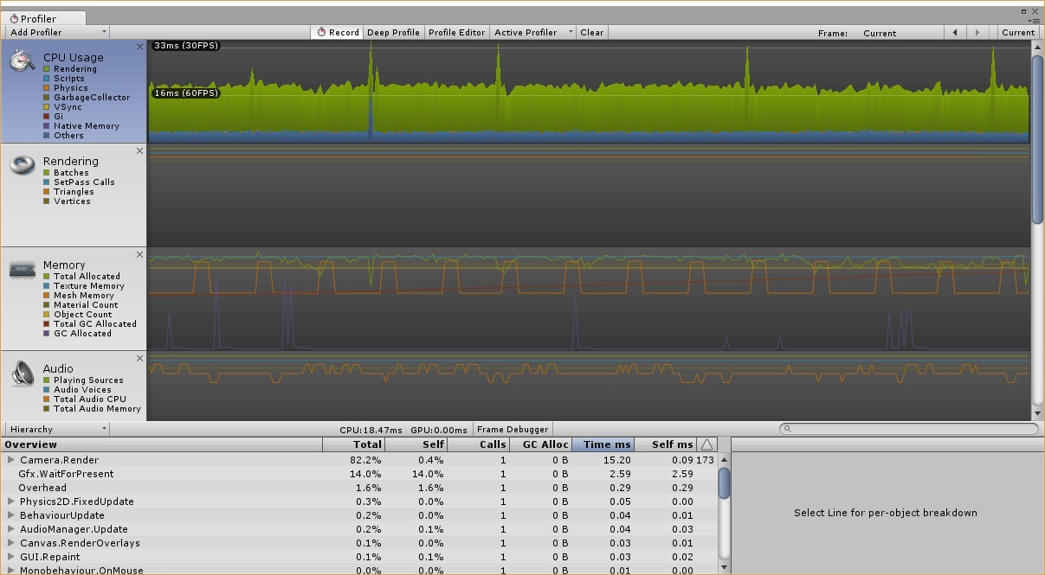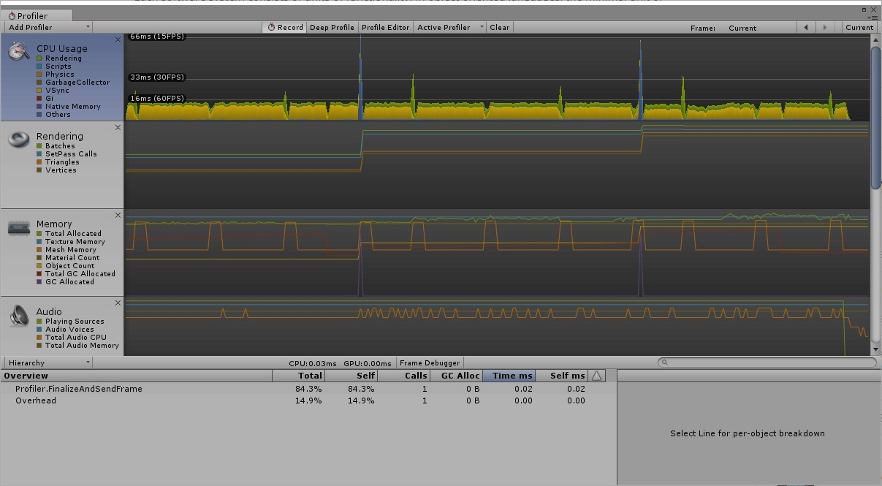*Figure 1: Frame rate per second for map generation Figure 2: frame rate per second for next-turn*

*Figure 3: Frame rate per second whilst moving around the map*

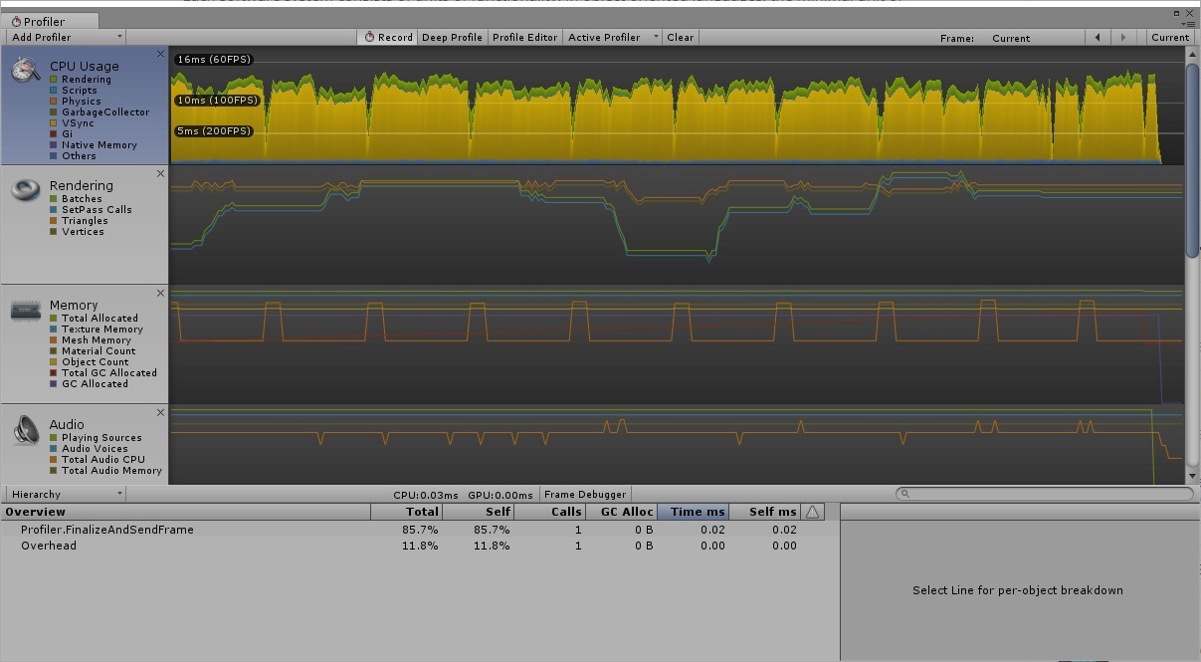

**3.3 Compatibility**

Compatibility is the degree to which our game can exchange information with other systems/components and perform its functions, whilst sharing the same hardware or software environment. Compatibility consists of coexistence and interoperability sub characteristics. Coexistence refers to the collaboration between products who share a common environment without having any negative impact on any other product. Interoperability refers to the how well two or more systems/components can exchange information and put the information exchanged to use. (Intentions shown in the figures A and B below).

**3.4 Usability**

Usability takes a range of factors into consideration, it refers to how well our game can be used by specified users to perform specified tasks e.g. make move keeping in mind the effectiveness, efficiency and satisfaction in a specified context of use. It also takes learnability and operability into account, which is how well a user can navigate around the product and carry out tasks. This links with our human computer interaction module where we evaluate user interfaces to see how well a user can carry out tasks set by the evaluator e.g. how long it takes for users to set their preferences – is it made explicit? Usability also considers user error protection which is the degree to which a product protects users against making errors, and the overall look of a UI which evaluates whether or not it is pleasing and satisfying the interaction of the user i.e. does it respond and let you know when you have pressed a button.

This aspect was tested by an end-user of the game, who was quite fascinated by the scope and depth. The user found it fairly easy to navigate through the main menu and get the game started as well as understand the underlying goal and principles of the game. *Figure 4: Usability test* (Intentions shown in the figures A and B below).

**3.5 Reliability**

Reliability is how well a system performs under specified conditions e.g. under a heavy load and for a certain period. This characteristic consists of several sub characteristics which it also looks for. Availability is one which measure the degree to which a product or component is accessible when required for use e.g. servers are reliable and not always down for maintenance or crashing. Fault tolerance is another characteristic which refers to how well our product can operate as intended despite a fault being present or detected at time of use. Reliability also looks into the recoverability of a system as a sub characteristic which measure the degree to which an interruption or failure of a product can be recovered e.g. data recovery and bring itself-back to a normal operational stage of the system. (Intentions shown in the figures A and B below).

**3.6 Security**

We need to make sure that data is kept confidential and protected i.e. ensure inputs are sanitised. Security also refers to the different views for different types of user. E.g. administrator would have a much more open view with unique functionality whereas users have a restricted view with limited functionality. Our user’s personal data needs to be kept confidential. Sub characteristics include integrity which as mentioned before we must ensure that that our game prevents unauthorised access to the program or data e.g. in html/SQL we prevent injections by sanitising all inputs and preventing or unauthorised data to be submitted which could change underlying software which may be fatal to the operation of the product. (Intentions shown in the figures A and B below).

**3.7 Maintainability**

Maintaining a system is crucial to its long existence. Software needs to be consistently updated and cleaned up. Low coupling and high cohesion support maintainability in that if one thing is changed it has minimal effect on other components of the system. Another aspect of maintainability is the ability to reuse a component if needed in another system, again, this can only be achieved if it has minimal links with other components.

Simply speaking, maintainable code is that which is easy to modify or extend. Furthermore, we could bring the concept of low coupling and cohesion in to the topic of maintainability as mentioned previously it should be each component should have one single functionality to ensure that code is easy to reuse and read.

In our source code, we tried our best to ensure that we follow a low coupling and high cohesion strategy as shown below in figure 4 to ensure that in the future maintainability will not be a problem. Most of the parts of the game had their own scripts and were independent of each other such as the tile, world controller and path finding scripts. They function minimal coupling and a high level of cohesion. We also ensured that code was commented so for the future software engineer updating software and components isn’t and problem and that code is easily readable separated in different classes for different functions thus ensuring that our software and process are of high quality.

We could have improved our maintainability by following the test-driven development approach to test as this would have led to the minimum amount required to pass the tests we had written beforehand thus ensuring that our process and software produced could have been of high quality. (Intentions shown in the figures A and B below).

*Figure 4: Highly cohesive class/unit*

**Screen shot of a highly cohesion part of the code**

**3.8 Portability**

Portability is the degree to which you can transfer a component of your system from one hardware, software or user environment to another. E.g. is our game able to run on different operating systems, or as mentioned previously is it able to run efficiently on university computers as opposed to our personal computers. The ability to adapt our game to different software, hardware and environments is important because of hardware evolution whereby eventually system will need updating and should be able to portably be maintained and run on new updated hardware or software.

Our intentions for achieving portability, which we played out in our previous report was to ensure that our game can run on any operating system regardless of their architecture. The reasons for doing it this way is to ensure that our game is not OS specific, this is also good for reusability as the components can be reused for the vast majority of OS. (Intentions shown in the figures A and B below).

**3.9 Reusability/Modularity**

Refers to, as mentioned above, ensuring that a component has on single functionality, so if needed it can be reused easily without having any ‘knock on’ effects, by this we mean it is not dependent upon other components. Our intentions from the previous report where to reduce coupling, use interface/abstract classes to limit amount of repeated code.

We achieved the software quality attribute reusability by ensuring that coupling was kept to a minimum, i.e. only necessary links are included to allow the system to cooperate with other components, in addition to this we ensured each component carried out on single function to allow reusability and good code readability e.g. can easily find a component when needed. Our reason for doing it this way is to allow future developers to take components from our system and to reuse it in their own work.

We could have improved on this software quality attribute by using code which was readily available i.e. royalty free code available to developers. (Intentions shown in the figures A and B below).

**4 Testing**

Testing involves identifying bugs, errors or any defects in a piece of software. It is the process of executing a program with the intent of finding errors. There are many guidelines which must be followed in order to ensure effective testing of our program. It was important that we ensured those conducting testing were not testing their own code as developers normally work with the developer mind-set of *"how to make this work?”* A good tester is thinking about *"how to break this?”*

There are different types of testing which can be used to detect and debug errors in software. Black-box testing is a method of software testing that examines the functionality of an application without peering into its internal structures or workings. White box testing uses specific knowledge of programming code to examine outputs.

Testing methods which are based on the complete scope of the software include unit testing which accommodates testing methods or 1-2 classes, integration testing which surrounds testing more classes or subsystems, function tests which allow us to test different features of the game and system test which involves testing the whole game.

Overall we have used a number of the methods specified above to effectively test and debug our software however unfortunately, this is one of the software attributes which we had a little bit of a problem with, as we were not very familiar with the workings of unity.

We could have improved the quality in our software and processes by using java to create our game, as we are all familiar with this language and I think we would have produced higher quality software and had followed a high-quality process schema. Testing would have been easier on this platform too; however, we wrongfully took advice to create our game in unity, however we can all agree this learning curve has given us experience and we have definitely learnt a lot over the past year.

Most of the testing which we conducted was unfortunately done after the coding process which was not ideal this was mainly due to the lack of experience with testing in unity. The types of testing which were conducted included black-box testing, unit testing and acceptance testing by the user As shown above in figure 1, 2, 3 and 4. After thorough consideration of the different testing methods we chose the three methods specified above as being the most appropriate in the limited amount of time we had left. (Intentions shown in the figures A and B below).

**4.1 Black-Box Testing**

Black box testing is the testing of the outputs of the programs

|  |  |  |  |  |
| --- | --- | --- | --- | --- |
| **Test#** | **Description** | **Test Data** | **Expected Outcomes** | **Actual Outcomes** |
| **1** | Check to see if the program runs without errors | Debug Program | Program should run without showing error message | Program starts without any problems |
| **2** | The options at the main menu do what they say | Start game ,help, audio quit | When start is pressed game runs, help opens help page, settings opens settings page | Each option does what it says |
| **3** | start option allows the game to initialise | Choose start in main menu | game starts with no errors | game starts with no errors |
| **4** | regenerate maps | press regenerate in menu | map regenerates castles | map regenerates castles |
| **5** | Mini game starts when entering a castle | player enters castle | minicamp opens in new window | Mini-game opens in new window |
| **6** | can the player attack | press next-turn | player attacks enemy | player attacks enemy |
| **7** | Can player move from one castle to another | move | player as well as units move in the corresponding direction | player as well as units move in the corresponding direction |

## 4.1.1 Screenshots;

In this screenshot, the game has opened without any errors, [1].

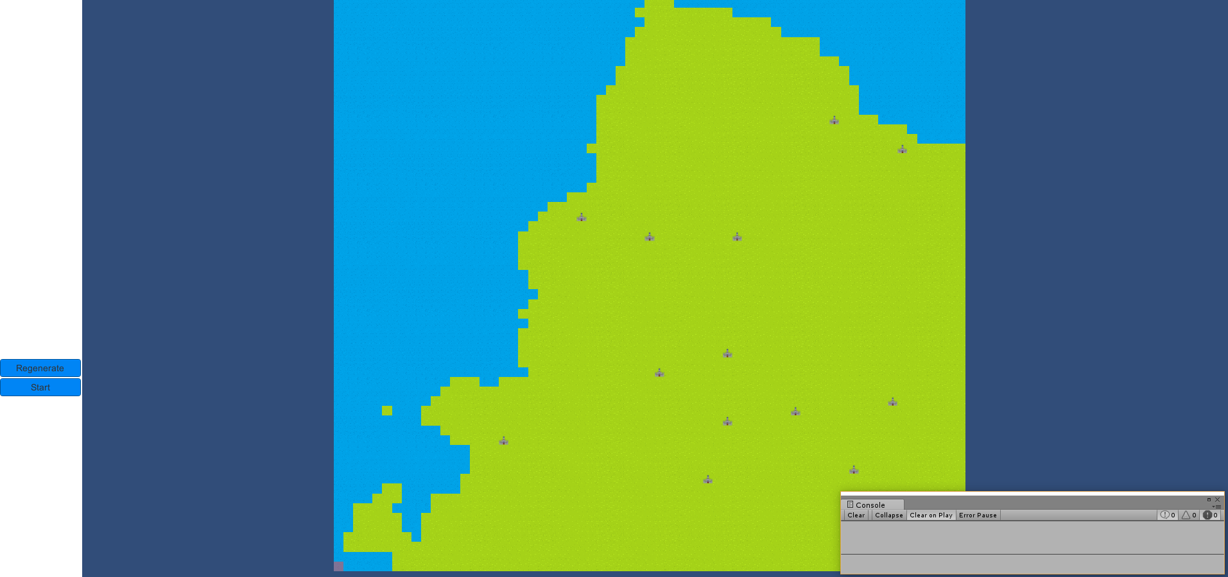

This is the main menu, options are provided for the user in this menu for him to choose from. All the options do what they say, [2].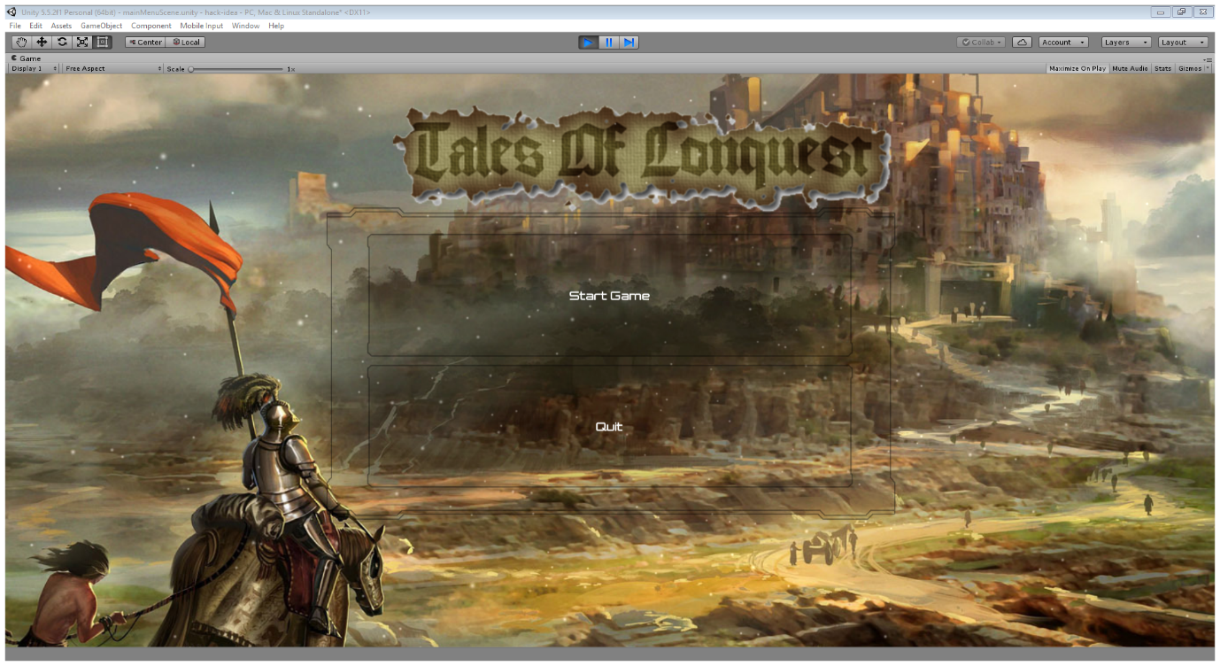

The start option allows the game to initialise, [3].

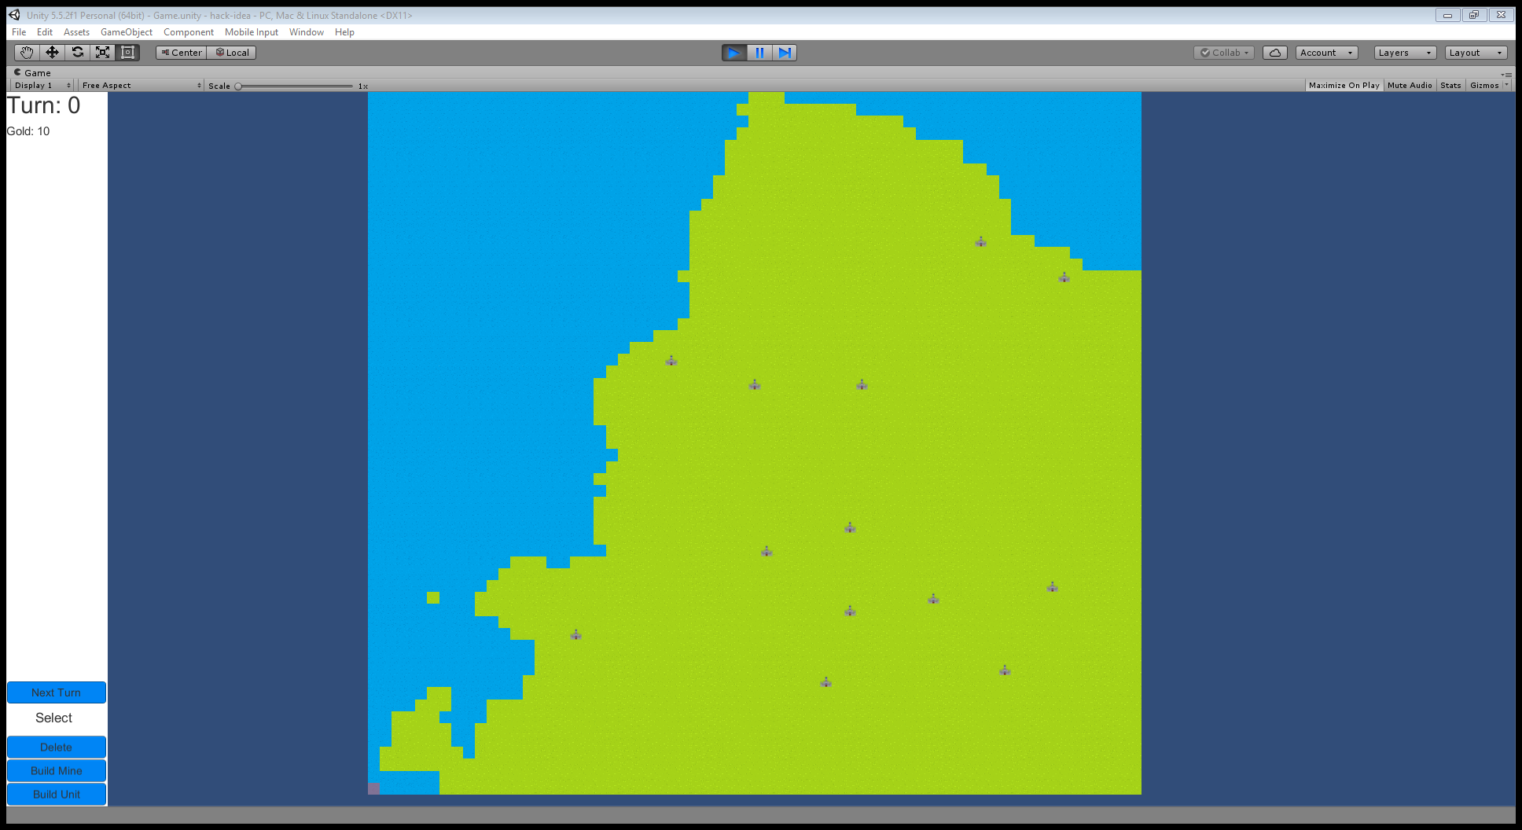

These screenshots show the map being regenerated [4]

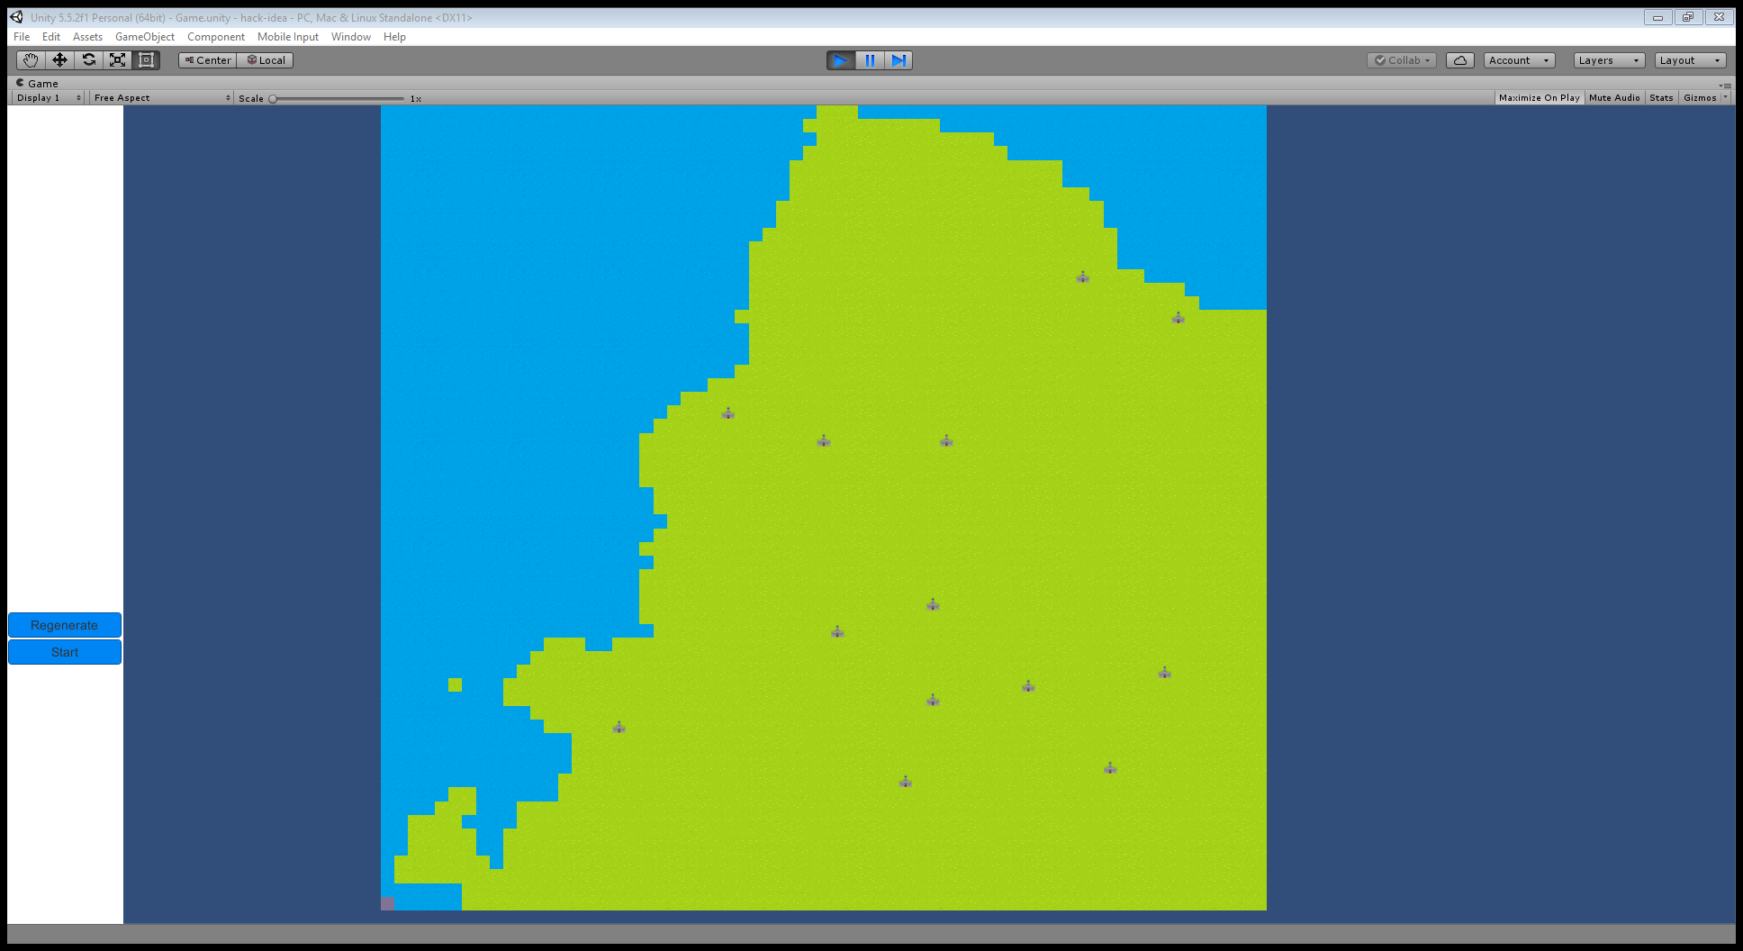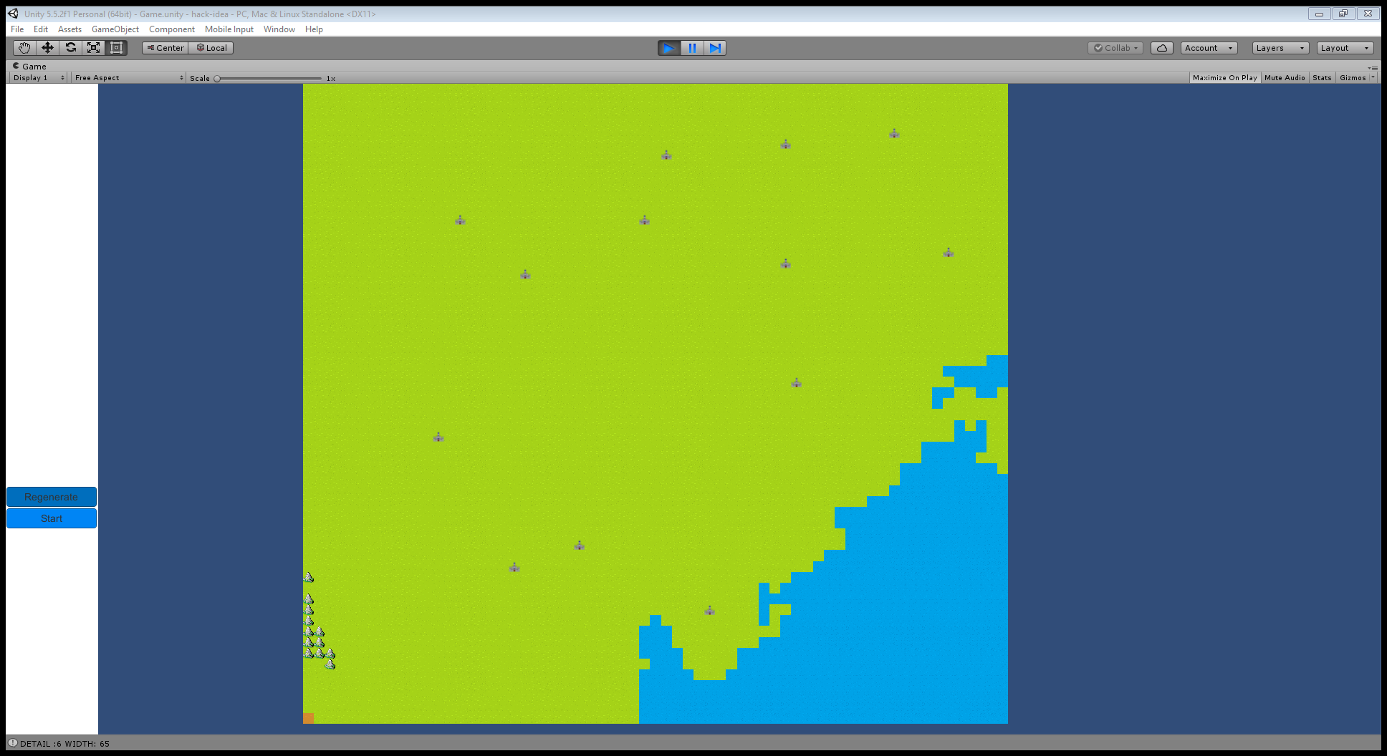

The following screenshot shows the mini-game [5].

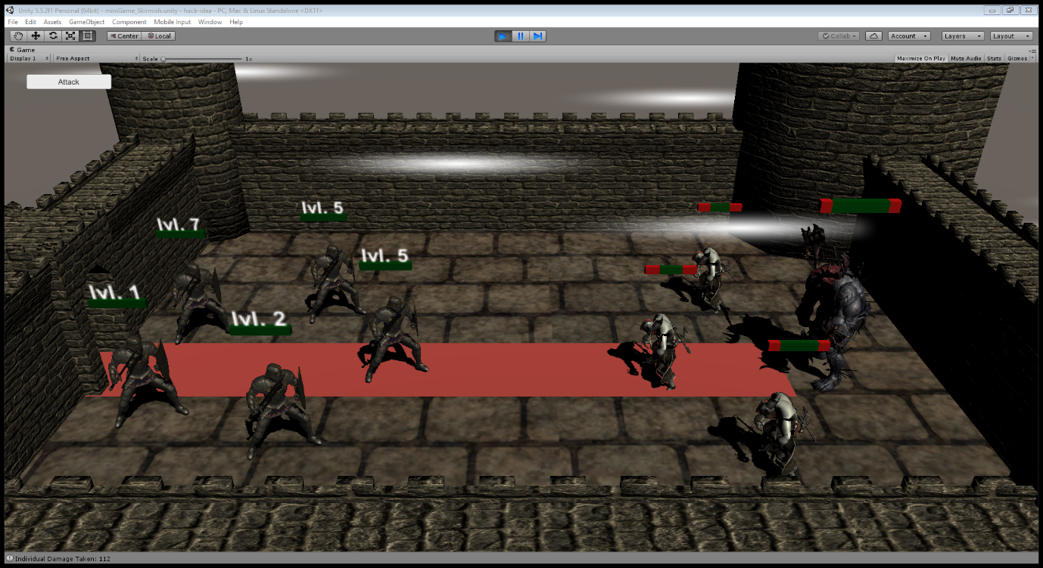

Player can move from one castle to another as well as attack, this completes tests [6] & [7].

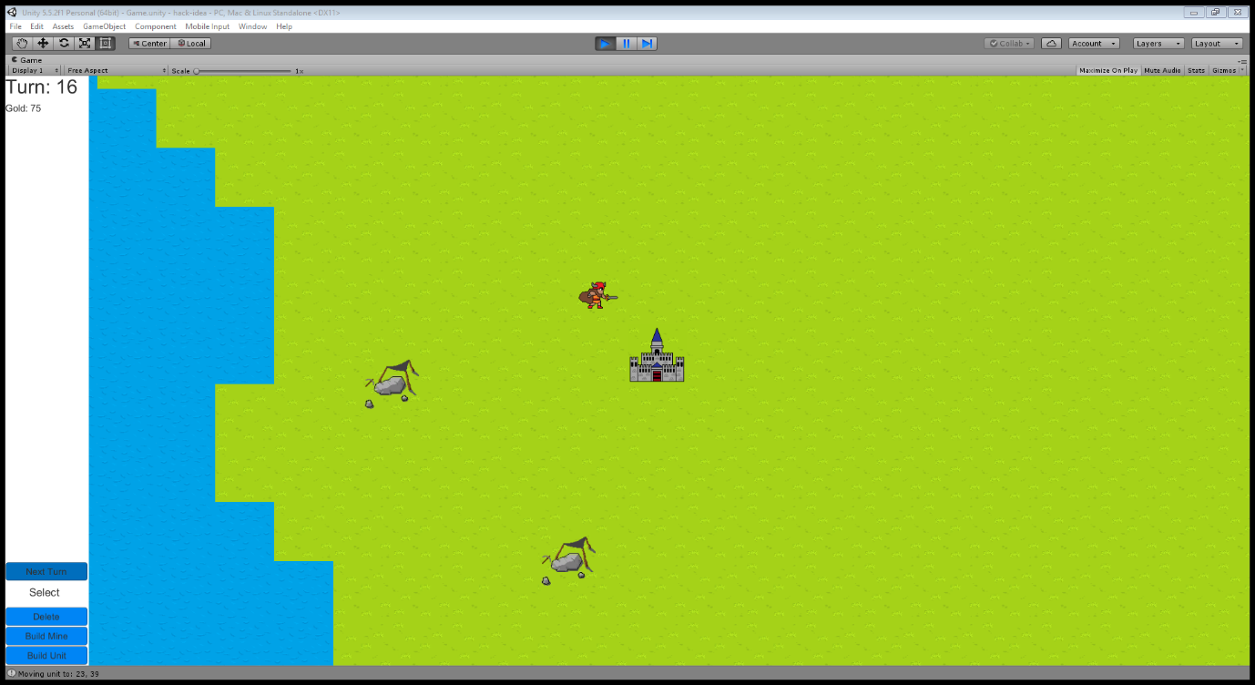

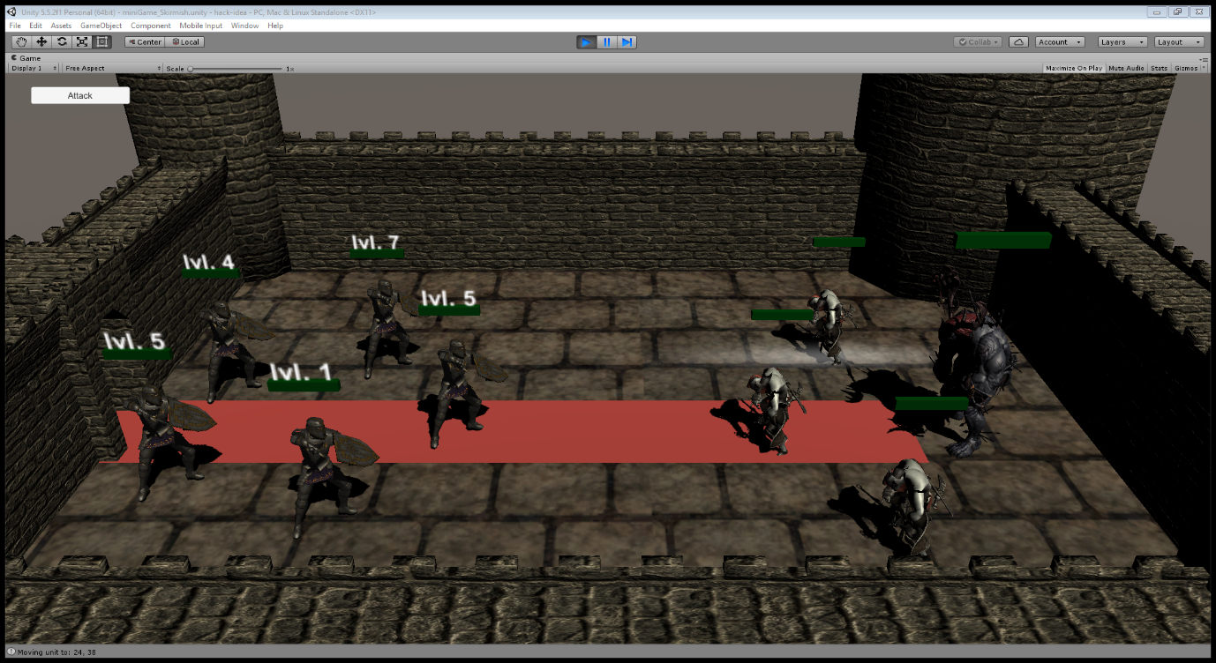

**4.2 Function Testing**

As part of the function tests, we investigated the different features of the game and decided to test the main menu option on a stand-alone basis as soon as it had been created and not implemented into the game. As shown in the figures below the main menu option functions correctly and the user can efficiently switch between 3 options.

*Figure 5: main menu Figure 6: Audio option Figure 7: Help option*#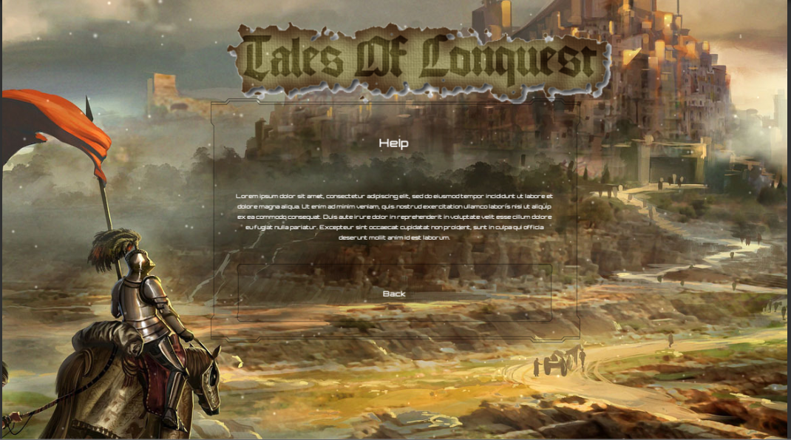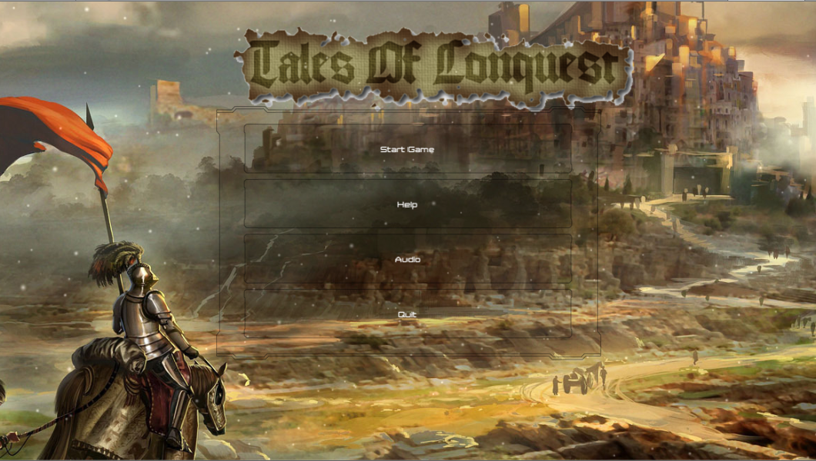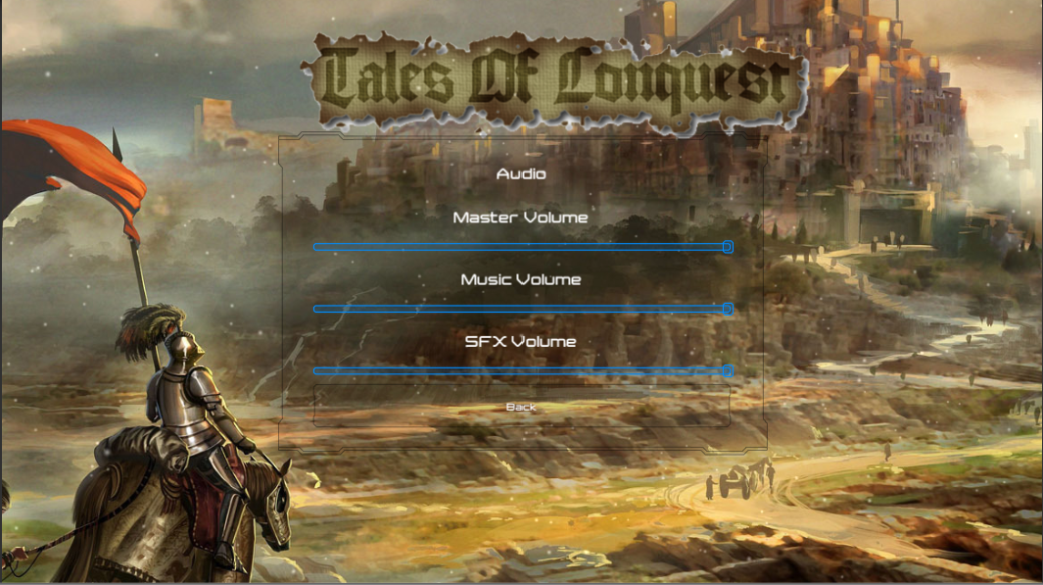

We also conducted function tests on both the player as well as enemy units before implementing them into the game as well, to find out whether they could attack or not. The outcome of these function tests were positive and both enemy as well as user units could attack as shown in the figures 7 and 8 below.

*Figure 8: Enemy attacking Figure 9: Player attacking*

**Screenshots of user and enemy units attacking**

**4.3 Acceptance testing**

Ad for acceptance testing we wrote down a list of instructions for the user to complete which allowed us to test how easy and straightforward our game was to operate. The results returned from one of the test we had conducted with an end user are shown below in figure 4. Overall the user was quite happy with how the game functioned and how easy it was to navigate to the different options and actions in the game. We conducted this acceptance test on 6 random people who had an interest in PC games.

*Figure 10: user feedback*

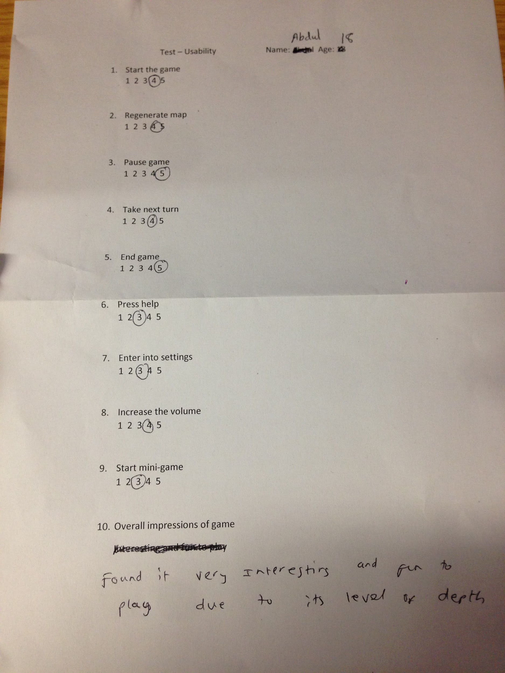

Most of the results showed that generally our game was quite straight-forward and easily navigable. Starting as well as quitting a game was pretty self-explanatory. The overall objective of the game could not be understood on first impressions however once into the game and the user had a more clear view of what can be done in the game the goal became easily understood.

In order to ensure we tested efficiently we would have been better suited to using the test driven development approach to developing our game. As writing tests before hand pinpoints the set functionality of each part of the software therefore if any bugs did occur they would only be minimal and would not require a change to the whole system.

**5 Software functional/non-functional quality**

Software functional quality is how well our game conforms to a given design, it evaluates the functional requirements i.e. how fit for purpose our game is and how it compares with other games. Although our game is like Civilisation it has a unique twist, which is that it includes mini games and therefore makes our game unique. Software structural quality refers to the non-functional requirements of our product which help us to measure the quality of our product and the processes used to create it.

**6 Meetings/Quality Processes**

Quality processes refers to how well we worked as a group, it consists of a set of procedures which we as a group followed to ensure that the deliverables produced as a team are ‘fit for purpose’

We held weekly meetings, where everyone in our group would meet up and create a plan of action for the week ahead. We would all assign a role to ourselves and discuss some of the things we can work on during the week. At the beginning of each meeting we would go around and discuss some of the progress we have made in the previous week to ensure that each of us are on track, we would also help each other resolve issues e.g. learning unity was new to us and therefore we suggested paired programming. Meetings where strictly 30mins to ensure that discussion was on topic and relevant details of the following weeks were discussed in time and the remainder 30 mins was used to start work and have sub group meetings e.g. the programmers, designers, testers would split up and have a separate meeting or start on the work. We had an assigned team leader who would, who we collectively chose as a group to take charge, mainly due to the fact of his experience and number of hours spent playing strategic games.

I think the process to engage with our group followed the structure of scrum although not daily but weekly. I think the process we followed was of high quality as we made significant progress by meeting up every week and setting targets for the following week, going off and achieving those and then coming back to set new targets this helped us iteratively develop our system and ensured that the quality of our software development was of high quality.

To improve the quality in our processes we could have held more regular meetings or even daily scrum meetings as opposed to weekly meetings whereby we meet up each day or every other day and set out our targets for the following day, and then at the next meeting expect to have achieved them so everyone is up to date on your situations and the team leader to fix any impediments we may have had. This would have given us a better understanding of the work which has been done and that which remains. Furthermore, group members would have been more committed in achieving tasks as they are obliged to attend meetings and report back on work carried out.

**7 Iterative process**

We opted for the iterative lifecycle to involve everyone in the group from the beginning. This is so all group members have an input in all aspects of the development of the product. With the iterative approach, we could constantly add to our game, although it being time consuming e.g. constantly testing and maintaining code I think the iterative approach is the best at ensuring that our software and process were of high quality. We could have improved the quality of our software and the processes by following each step in the iterative lifecycle e.g. requirements, design, implementation, testing, evaluation etc.

Testing was the step which we were lenient on and because of the time capacity we decided it would be best to leave it to the later stages hence may suggest problems later which are irrecoverable because they were not detected at the time because we did not test at the time of implementation as much as we would have liked to. One way we could improve to ensure that our software and processes where of high quality is to have used the TDD test driven development way of testing i.e. write tests before writing the code, this ensures that only the required amount of code is written which is enough to allow the test to pass hence improving maintainability.

**8 How we functioned as a team**

As a team, we functioned very well, meetings took place regularly and everyone attended, everyone was informed via group chat if a member could not attend a meeting and notes were made for the absentee to read and catch up at a later stage. Within our group, we had subgroups or ‘partners’ which we work well together, this strengthened our group further as we were able to partner up with people who we felt comfortable with. All source code was managed using git to allow us to keep a record of our development and to allow us to collaborate and update our product every time a change is made to ensure all of us were notified. So, we can organise our project we used to Trello to set deadlines and upload files at a central location for everyone to see, edit, make and suggest changes. Our team working collaboratively on different environments helped us to ensure that our software produced and processes where of high quality.

One thing which could have improved the quality in our software and processes

**9 What worked what didn’t?**

* Time allocation - getting together with our group and working on our product was something which worked really well in our group, we held meetings on the allocated slots on Thursday and Fridays which ensured that all of us were free as it was a timetabled slot.
* Different ideas - our initial idea of the game started out with it being based in an office building however this slowly evolved to the game we have today ‘Tales of conquest’, map control strategy game based in the ancient era.
* Changing ideas - ideas did change due to unforeseen circumstances, the theme of it being set in the ancient era changed slightly to allow goblins, elves to be integrated into the game despite the specific theme we chose because of the simple fact that the skins for the characters in unity cost money, and none of us were willing to buy them, so we used the generic items we could find online. We did change the game from 3d to 2d and then to top level view, with the minigames going from 3d to 2d.

**10 What was achieved VS what was planned**

In general the overall game did come out as we planned, along with some minor tweaks along the way. One thing which we did lack in was writing tests, although we did test the functionality thoroughly as we were coding I think we could have spent a lot more time testing to ensure that our software produced and processes where of high quality. Below is a very vague plan of what was planned from after the MVP was handed in. We had set clear goals on what needs to be achieved for the final product. We used this plan to ensure that our software produced and processes are of high quality.

**10.1 Plan Figure A**

|  |  |  |
| --- | --- | --- |
| Milestone | Activity | Date due |
| The Complete software (meeting) | First meeting back after Christmas getting familiar with the work done | Tuesday 17th January |
| The Complete software (meeting) | Meeting on ways to further develop the game both front- end and back-end | Friday 28th October |
| The Complete software (present ideas) | Present ideas on extending the game and their feasibility | Wednesday 1st February |
| The Complete software (research) | Conduct background research on how to improve the game, could also met up with the games critic or group mentor to gain more understanding | Wednesday 15th February |
| The Complete software (meeting) | Discuss how this extended functionality will be implemented etc. | Friday 24th February |
| The Complete software (prototype 1) | Present Extended functionality one aspect at a time / mini games | Wednesday 8th March |
| The Complete software (meeting) | Discuss how to improve code and extend functionality further | Wednesday 15nd March |
| The Complete software (prototype 2) | Present extended functionality /integration testing/regression testing | Wednesday 22th March |
| The Complete software (meeting) | Meeting to discuss any final improvements /Testing | Wednesday 29th March |
| The Complete software (prototype 3) | Final prototype presenting the implemented functionality and efficiency /Testing | Friday 31st March |
| The Complete software (prototype 4) | Bring together the software product and fix any bugs ensuring it is ready to hand in. /Testing | Tuesday 4th April |

**10.2 Quality Assurance plans Figure B**

The different sections e.g. maintainability testability etc. above explain what was achieved, figures A and B portray our plan and our intentions for the remainder of the project as stated in the quality assurance report.

|  |  |
| --- | --- |
| Quality Attribute | Intentions |
| Maintainability | For the remainder of the project we will ensure that our code is easy to find, commented, and specific components are found easily and try and avoid any ‘knock on’ effects by ensuring components are independent to avoid any chain breakages where one component breaks down causing several other dependent components to also break down. Doing this will ensure our software and processes are of high quality. |
| Reusability | For the remainder of the project our intentions are to code in such a way that components can be reused. Ways of doing this include reducing coupling and making 1 single unit carry out 1 task (as mentioned above), using interface and abstract classes, ensuring code is written in an extensible manner and trying not to repeat code. This would in turn improve the quality of our software and processes. |
| Testability | For the remainder of the project our intentions are to start writing tests based on the TDD approach and to start testing the product along with individual unit testing (regularly as we go). Testing continuously ensures that software and processes are of high quality. |
| Efficiency | For the remained of the project we will try and achieve this by removing any unnecessary code, reuse code where possible, follow coding practices, to produce code which is consistent and ensures data integrity – thus ensuring that our software and process are of high quality. |
| Modularity | Our intention for the remainder of the project is to achieve modularity i.e. having several separate AI’s which have specific purposes. |
| Portability | For the remainder of the project we will try and improve on our portability standard by choosing either running on a specific OS or making it portable to be able to be run on any OS. |

**11 Conclusion**

Overall I think the project as a whole was a new experience for all of us and a huge learning curve in terms of software development. The outcome of the project is that we tried our best to ensure that software produced and processes where of high quality although as with all things improvements could definitely be suggested if we had to do this project again in its entirety.

Although the software produced and processes are to be of high quality I think a lot of other factors override their importance such as functionality e.g. if the software produced is messy, unreadable but the functionality works then we could say as long as it does its jobs that it is fine, although it goes against the software quality attributes and violates high quality software.

Overall we could have improved on our processes a little better to ensure that our methods and software were of the highest quality possible for example the TDD approach to testing could have been considered at the start of the project. Although it could be dangerous testing software at the end of its development we used approaches which worked best for us and tested functionality of to ensure that the software produced was of high quality and that improvement needed were at a minimum and did not endanger the entire software.

As a group we all had separate roles and definitely worked great together even when tensions were running high during the end, communication throughout the year was really good, however could have been improved during the final deadline date when everyone was frantically trying to get work done and a few final meetings were cancelled to give members more time in completing the product on time. Overall this did ensure that our process and software produced was in fact of high quality.

**12 References**

* *Why developers should not test their own work?* <http://softwareengineering.stackexchange.com/questions/77146/why-to-let-not-let-developers-test-their-own-work>
* *What is tearing?* <https://www.reddit.com/r/pcgaming/comments/35d01h/what_causes_screen_tearing/>
* *What is so great about civilisation?* <https://www.reddit.com/r/gaming/comments/1jz1am/whats_so_great_about_civilization_v/>
* *Top 10 strategy games on pc* <https://www.pcgamesn.com/15-great-strategy-games-you-really-should-play-or-else>
* *What is a software quality model composed of?*<https://www.iso.org/about-us.html>